**Language:**

* English - Intermediate

**Soft Skills:**

* Communication
* Team player
* Stress-resistant
* Self-learning
* Active learning
* Purposefulness

**Skills:**

* Networking
* Bash & Powerhell
* AWS & Azure
* Nginx & Apache
* Terraform
* Ansible
* Jenkins
* Docker
* Git
* PostgreSQL
* Microsofr SQL Server
* Windows Server

**KOZLOV NIKITA**

DevOps Engineer

An ambitious and highly motivated DevOps Software Egineer with strong

communication skills. I am actively engaged in self-education and seriously

determined to realize myself in the field of DevOps.  
I like rollerblading, playing guitar, doing computer graphics.

**Experience**:

DevOps Engineer Trainee  
PlaysDev (Nov 2022 – Feb 2023)

* Configuring the Nginx Web Server: DNS, proxying, balancing, logging, ssh/tls certification (AWS EC2)
* Configuring Bastion and Private Hosts (AWS VPC, AWS EC2)
* Creating an instance for a PostgreSQL database, snapshots and backups setting (AWS RDS, AWS Backups)
* Creating static Page hosting (AWS S3, AWS CloudFront)
* Raising the environment with python (AWS IAM, AWS CLI, Python boto3)
* Raising the environment with Terraform
* Configuring Nginx Web Server using Docker (Nginx, Dockerfyle, Dockercompose, DockerHub)
* Configuring Application Load Balancer with Nginx in Docker (AWS ECS, AWS LB, AWS EC2, Fargate, Docker, DockerHub)
* Working with Git
* Configuring and setting up environment using Ansible (AWS EC2, AWS VPC)
* Setting up CI/CD processes using Jenkins (Git, GitHub Hooks, Docker Hub, AWS EC2)

Cloud and DevOps courses  
EPAM Systems (Jan 2022 – Apr 2022)

* Creating and configuring virtual machines (Microsoft Azure)
* Creating services (Active Directory)
* Configuring server, creating organization units and forests (Windows Server, Active Directory)
* Setting up a web page and it’s accessible (Internet Information Services)
* Creating Database, it’s snapshots and backups (Microsoft SQL Server)

DevOps Fundamentals courses  
EPAM Systems (Nov 2021 – Dec 2021)

* Setting up networks, dividing the network into subnets
* Writing Bash and Powershell scripts (Bash, Powershell)
* Creating and configuring virtual machines, configuring the network between them (Hyper-V, Windows Server)

**Contacts:**

* +375298935062
* nkozlov.etc@gmail.com
* https://t.me/Ngoatov

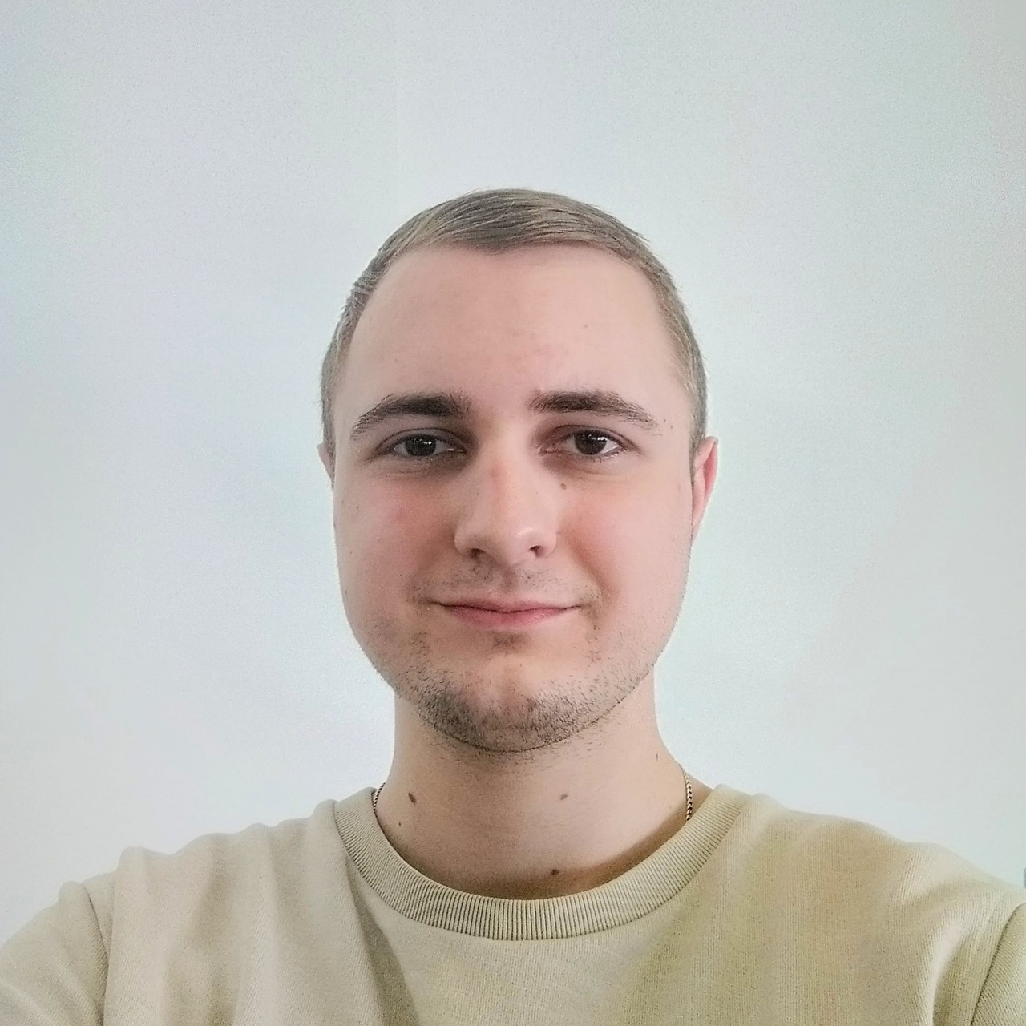

**Education**:  
Vitebsk State University named by P.M. Masherov   
(Information technology software)  
2019 – 2023